Course no. 66-110-01-05-07 Date of exam: 23.3.14
Subject: Mathematics for economists
Dr. Iron, Ms. Rosenwasser
Duration of the exam: three hours

The discipline committee warns!
It is forbidden to remove the questionnaire from the exam room or copy it or photocopy it or mark it with a magic marker. It is absolutely forbidden to go to the lavatory. Once you have received the questionnaire/notebook, you must take the exam and return it. You may leave the exam room only after half an hour. It is forbidden to talk during the exam. Please comply with the supervisor’s instructions. Remove electronic devices and mobile phones. Holding a mobile phone, even if switched off, will lead to immediate invalidation of the exam. A student found with forbidden auxiliary material or caught cheating will be severely punished and may even be expelled from the university. A complaint will be submitted to the discipline committee against anyone transgressing these instructions.

I herewith declare that I have read and understood the instructions on the questionnaire and that I have no material in my possession that is forbidden for use.
ID no. ___________________ Signature ___________________________

Instructions

The exam contains 15 multiple questions. Answer all the questions. Choose the correct answer and indicate it on the attached answers sheet.
If you indicate two answers, the answer will not be included in the count of correct answers. No auxiliary material may be used. A calculator can be used for calculations. The exam sheets and the notebook can be used for calculations. In no case will these pages be taken into account in determining the grade. You must return the exam sheet together with the answers sheet and the draft notebook.

GOOD LUCK!

Note: Two answers were accepted in question 15 – answer no. 1 and answer no. 3

Question no. 1
Which theorem is not correct?
1.  2.  3.  4. |  | 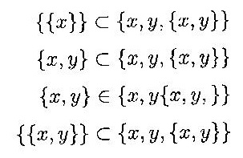

Question no. 2
Which theorem is correct?
1.  2.  3. |  | 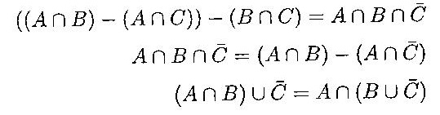
4. None of the other answers are correct.

Question no. 3
Which statement is correct?
- If f(x) is an odd function, then the function of its derivative, f’(x), is an even function.
- If f(x) is an even function, then the function of its derivative, f’(x), is also an even function.
- A linear function is an odd function.
- A second degree function is an even function.

Question no. 4
Given the function:
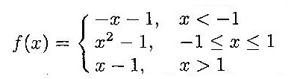
Which is the correct statement?
- The function f(x) is even.
- The function f(x) is odd .
- The function f(x) is not even and is not odd.
- An inverse function exists for the function f(x).

Question no. 5
Let f(x) be a continuous function in the domain [a, b] and it is given that f(a) ⋅ f(b) < 0, the:
- For the function 1/f(x), there exists at least one point in the domain [a, b] where it is not continuous.
- The function 1/f(x) is continuous at every x in the domain [a, b].
- For the function f(f(x)) there exists a point in the domain [a, b] where the value of the function is zero.
- None of the other answers are correct.

Question no. 6
Given the function 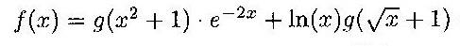and given 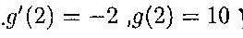, then:
1.  2.  3. | 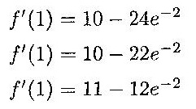
4. None of the other answers are correct.

Question no. 7
The limit: 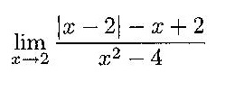is:
- The function does not have a limit at the point x = 2.
- –0.5
- 0
- None of the other answers are correct.

Question no. 8
The limit 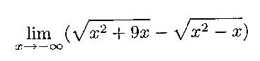 is:
- –5
- 5
- 0
- –4

Question no. 9
The limit 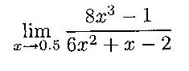 is:
- 6/7
- 1/7
- 2/3
- None of the other answers are correct.

Question no. 10
The limit 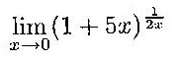 is:
- e^{2.5}
- 1
- e
- None of the other answers are correct.

Question no. 11
Given the function: 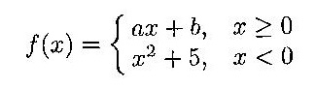
If it is known that the function is differentiable at point x = 0, then:
- a = 0, b = 5
- a = 1, b = 0
- There are not enough data for a deduction.
- None of the other answers are correct.

Question no. 12
Given the function: 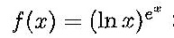
therefore:
1.  2.  3. | 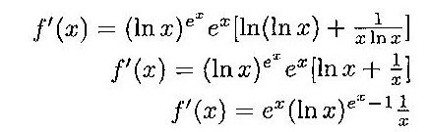
4. None of the other answers are correct.

Question no. 13
Given the function: 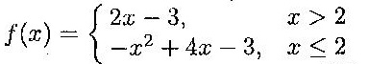, then:
- An inverse function exists for function f(x).
- An inverse function does not exist for function f(x).
- Function f(x) is continuous and differentiable at point x = 2.
- None of the other answers are correct.

Question no. 14
Given the function:
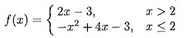
Then:
- in the domain x ≤ 2.
- 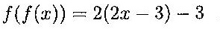in the domain x > 2
- f(f(x) receives different values in four domains.
- None of the other answers are correct.

Question no. 15
Given the functions 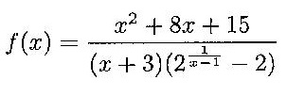
Which statement is correct?
- At point x = –3 the function has a removable discontinuity point.
- The function has exactly two discontinuity points.
- At point x = 1 the function has a removable discontinuity point of the first type.
- None of the other answers are correct.

