Course no. 66-110-01-05-07 Date of exam: 5.2.14
Subject: Mathematics for economists
Dr. Iron, Ms. Rosenwasser
Duration of the exam: three hours

The discipline committee warns!
It is forbidden to remove the questionnaire from the exam room or copy it or photocopy it or mark it with a magic marker. It is absolutely forbidden to go to the lavatory. Once you have received the questionnaire/notebook, you must take the exam and return it. You may leave the exam room only after half an hour. It is forbidden to talk during the exam. Please comply with the supervisor’s instructions. Remove electronic devices and mobile phones. Holding a mobile phone, even if switched off, will lead to immediate invalidation of the exam. A student found with forbidden auxiliary material or caught cheating will be severely punished and may even be expelled from the university. A complaint will be submitted to the discipline committee against anyone transgressing these instructions.

I herewith declare that I have read and understood the instructions on the questionnaire and that I have no material in my possession that is forbidden for use.
ID no. ___________________ Signature ___________________________

Instructions

The exam contains 15 multiple questions. Answer all the questions. Choose the correct answer and indicate it on the attached answers sheet.
If you indicate two answers, the answer will not be included in the count of correct answers. No auxiliary material may be used. A calculator can be used for calculations. The exam sheets and the notebook can be used for calculations. In no case will these pages be taken into account in determining the grade. You must return the exam sheet together with the answers sheet and the draft notebook.

GOOD LUCK!

Question no. 1
Which theorem is correct?

1.  2.  3. | 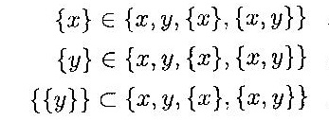
4. None of the other answers are correct.

Question no. 2
Which theorem is not correct?
1.  2.  3.  4. |  | 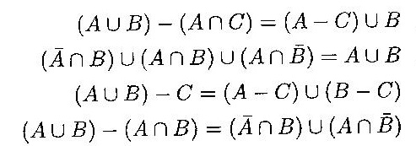

Question no. 3
Which statement is correct?
- If f(x) is an odd function, then f(f(x)) is also an odd function.
- If f(x) and g(x) are bounded functions, then f(x) ⋅ g(x) as well as f(x) / g(x) are bounded functions.
- The derivative of f(g(x)) is equal to the derivative of g(f(x)).
- None of the other answers are correct.

Question no. 4
Given the function:
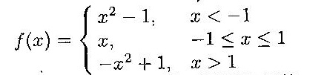
Which is the correct statement?
- The function f(x) is odd.
- The function f(x) is even .
- The function f(x) is not odd and is not even.
- An inverse function exists for the function f(x).

Question no. 5
Let f(x) be a continuous and differentiable function in the domain: 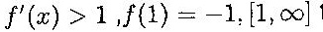 for every x in the definition’s domain (the given domain). Then the theorem f(x) = 0:
- Has a root in the section (1,2) and it is single.
- There is a single root but it cannot be determined in which section.
- It is possible that there is more than one root in the definition’s domain.
- None of the other answers are correct.

Question no. 6
Given the function 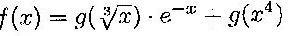and given 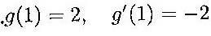, then:
1.  2.  3. | 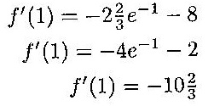
4. None of the other answers are correct.

Question no. 7
The limit: 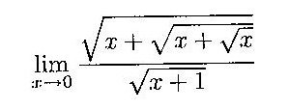is:
- 1
- 0
- ∞
- None of the other answers are correct.

Question no. 8
The limit 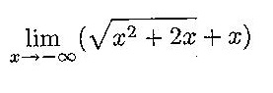 is:
- –1
- –∞
- 0
- None of the other answers are correct.

Question no. 9
The limit 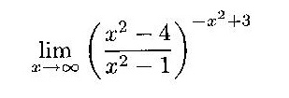 is:
- e³
- e^{–3}
- e
- None of the other answers are correct.

Question no. 10
Given the function: 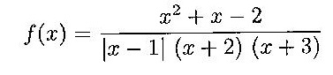
Which statement is correct?
- The point x = –2 is a removable discontinuity point.
- If f(–2) = 1, then the function is continuous at point x = –2.
- The point x = –3 is an essential discontinuity point of the first type.
- None of the other answers are correct.

Question no. 11
Given the function: 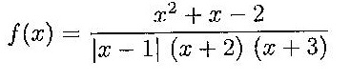
Which statement is correct?
- The point x = 1 is an essential discontinuity point of the first type.
- The point x = 1 is a removable discontinuity point.
- If f(1) = 0.25 the function is continuous at point x = 1.
- None of the other answers are correct.

Question no. 12
Given the function: 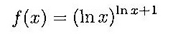, then:
1.  2.  3.  4. | 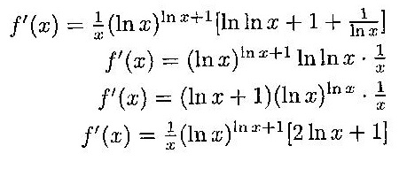

Question no. 13
Given the functions:

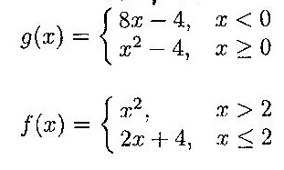
Then:
1.  2.  3. | 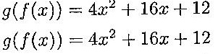 | only in the domain –2 ≤ x ≤ 2  in the entire domain x ≤ 2
 | 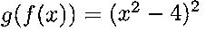 | in the domain x > 2
4. None of the other answers are correct.

Question no. 14
If 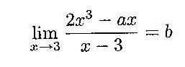 then:
- a = 18, b = 36
- a = 18, b = 12
- a = 9, b = 6
- None of the other answers are correct.

Question no. 15
Given the functions 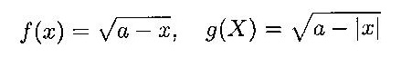, where a > 0. Which statement is correct?
- An inverse function exists for function f(x).
- The two functions are identical.
- An inverse function exists for function g(x).
- None of the other answers are correct.

