Course no. 66-110
Subject: Mathematics for economists
Duration of the exam: two and a half hours

1. Express your opinion and explain each of the following claims:

A.  B.  C. | 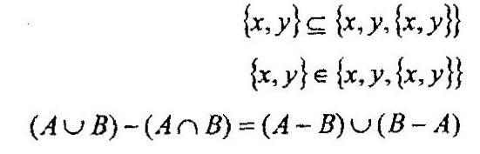
- The vertex of the parabola f(x) = ax² + bx – 2 is located in the first quadrant (not on the axes). Then the following exists: b² + 8a > 0, a < 0
- f(x) = ln5 + 7, then f’(x) = 1/5
- f(x) is differentiable for any x and it is given that f’(1) = 2 and f(1) = –1. We will define 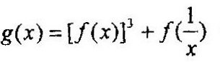. Then g’(1) = 8
- The function 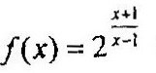 is an injective (one-to-one) function.
- 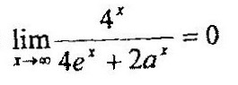for any a.
- f(x) is defined for every x, g(x) = f(–x²), then g(x) is an odd function.
- f(x) is defined for every x, g(x) = f(–x³), then g(x) is an even function.

2. Calculate the following limits:
A.  B.  C. | 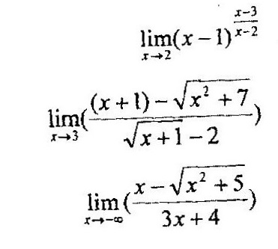

3. Given the function: 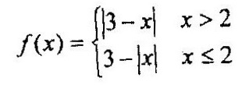
- Determine whether an inverse function exists for f and if so, find it.
- Determine whether f is even, odd or neither odd nor even.
- Calculate f(f(x))

4.
- Calculate a and b such that the function will be continuous.
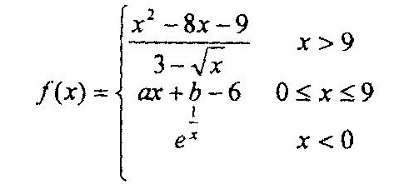
- For a and b that you found in section A, find f’(x)

5. Differentiate the function 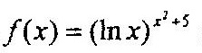

GOOD LUCK!

