Course no. 66-110
Subject: Mathematics for economists
Duration of the exam: two and a half hours

1. Express your opinion and explain each of the following claims:

A.  B.  C. | 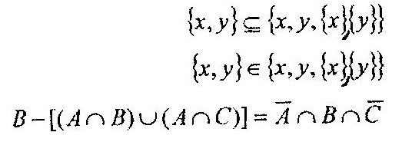
- The equation x³ + 4x – 1 = 0 has one solution.
- If f(x) is continuous and differentiable at point x = 0, and if f’(0) = 2 and f(0) = 3, then 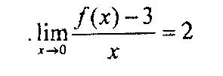
- The function 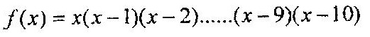 fulfills f’(0) = 0.
- The function 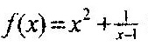receives the value zero in the section (0,2).

2. Given the function 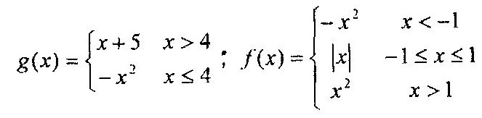
- Determine and explain whether function f(x) is even, odd, or other.
- Is g(x) an injective (one-on-one) function? If so, calculate its inverse function.
- Calculate f(g(x)).

3. Given the function: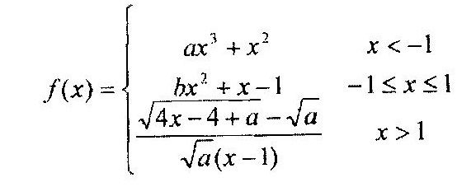
What must a and b be so that the function will be continuous at every point?

4. Calculate the following limits:
A.  B. | 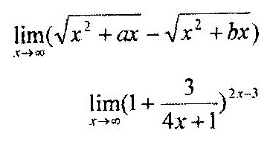

3. Differentiate the following functions:
A.  B. | 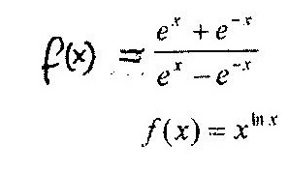

GOOD LUCK!

