Course no. 66-111 Date of exam: 18.9.14
Subject: Mathematics for economists
Duration of the exam: three hours

The discipline committee warns!
It is forbidden to remove the questionnaire from the exam room or copy it or photocopy it or mark it with a magic marker. It is absolutely forbidden to go to the bathroom. Once you have received the questionnaire/notebook, you must take the exam and return it. You may leave the exam room only after half an hour. It is forbidden to talk during the exam. Please comply with the supervisor’s instructions. Remove electronic devices, beeper and mobile phone. Holding a mobile phone, even if turned off, will lead to immediate invalidation of the exam. A student who will be found with forbidden auxiliary material or who will be caught cheating will be severely punished and may even be expelled from the university. A complaint will be submitted to the discipline committee against anyone transgressing these instructions.

I herewith declare that I have read and understood the instructions on the questionnaire and that I have no material in my possession that is forbidden for use.
ID no. ___________________ Signature ___________________________

Instructions

The exam contains 17 questions. Answer all the questions. Choose the correct answer and indicate it on the attached answers sheet.
If you indicate two answers, the answer will not be included in the count of correct answers. No auxiliary material may be used. A calculator can be used for calculations. The exam sheets and the notebook can be used for calculations. In no case will these pages be taken into account in determining the grade. You must return the exam sheet together with the answers sheet and the draft notebook.

GOOD LUCK!

Question no. 1
The limit 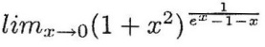 is:
- e²
- 2
- e
- None of the other answers are correct.

Question no. 2
The limit 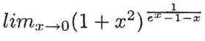 is:
- 3/e
- 1/e
- 0
- None of the other answers are correct.

Question no. 3
Ths solution of the integral 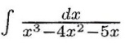 is:
1.  2. | 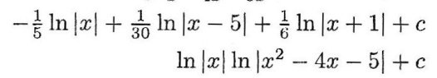
- We do not have the tools for solving this integral.
- None of the other answers are correct.

Question no. 4
The solution of the integral 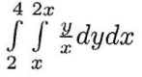 is:
- 9
- 5.75
- 12.2
- None of the other answers are correct.

Question no. 5
The solution of the integral 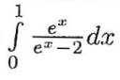is:
- ln (e – 2)
- e
- The integral is not defined.
- None of the other answers are correct.

Question no. 6
The solution of the integral 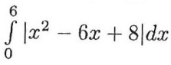 us:
1.  2.  3. | 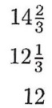
4. None of the other answers are correct.

Question no. 7
Given a continuous function f (x), such that f (0) > 0. Which statement is correct?
1.  2.  3. | 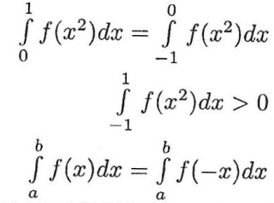
4. None of the other answers are correct.

Question no. 8
The function 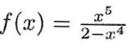. Therefore:
- The line y = -x comprises a right asymptote of the function.
- The line y = x comprises a right asymptote of the function.
- The right asymptote of the function is different from the left asymptote.
- The function does not have a right asymptote.

Question no. 9
The function 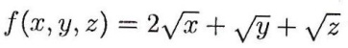, under the constraint x + y + z = 120:
- Has only one point that is suspected of being an extremum and it is (80, 20, 20).
- Has four points that are suspected of being extrema.
- Has only one point that is suspected of being an extremum and it is (60, 30, 30).
- None of the other answers are correct.

Question no. 10
The approximate value of the expression 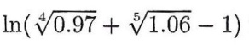, with the help of the differential, is:
- 0.0045
- 0.0135
- 0.027
- None of the other answers are correct.

Question no. 11
Given the function F (s, t), homogeneous of degree 4, and given 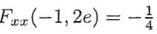. It is defined that: 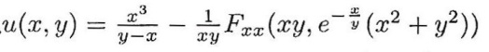
Therefore, 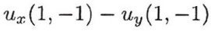is equal to:
- -1.5
- -1
- 0
- There are not enough data in order to solve the question.

Question no. 12
Given the function: 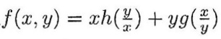
Therefore, is equal to:
- 0
- 1
- Additional data regarding functions h and g are necessary in order to solve the question.
- The value of function f at a specific point is necessary in order to solve the question.

Question no. 13
Expansion of a Taylor series of the function x³ ln x around the point x = 1 is:
1.  2.  3.  4. | 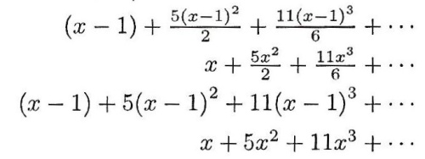

Question no. 14
The limit 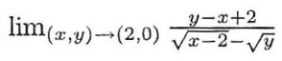 is:
- 0
- The limit does not exist.
- 1
- None of the other answers are correct.

Question no. 15
f (x, y) is a function with two variables, homogeneous, of degree 3.
Given: 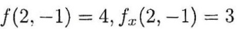
Therefore, the value of the expression 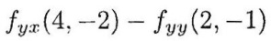is:
- -12
- 15
- -6
- None of the other answers are correct.

Question no. 16
Given the function: 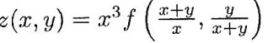
Then 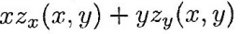is equal to:
- 3z (x, y)
- z (x, y)
- 0
- It cannot be calculated because there are not enough data on function f.

Question no. 17
Given the function: 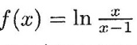
Claim A: The domain of the definition of the function is x < 0 or x > 1.
Claim B: The function is concave in the domain x < 0 and convex in the domain x > 1.
Claim C: The function has one extremum point.
- Only claims A and B are correct.
- Only claim A is correct.
- All the claims are correct.
- Only claims B and C are correct.

