Course no. 66-111 Date of exam: 2013 moed B
Subject: Mathematics for economists
Duration of the exam: three hours
Auxiliary material: a calculator

1. Calculate the following limits:

A.  B.  C. | 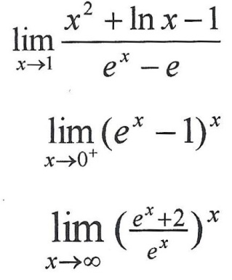
2. Calculate the following integrals:
A.  B.  C. | 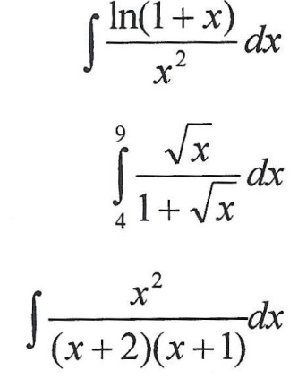
3. Investigate the function 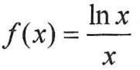 and draw its graph.

4. Calculate the minimum, maximum and saddle points of the function:
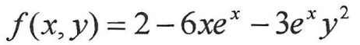
5. Given function f (x, y) in two variables and it is known that it is homogenous of
degree 3. Given: 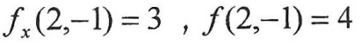. Calculate the following expressions:
A.  B.  C. | 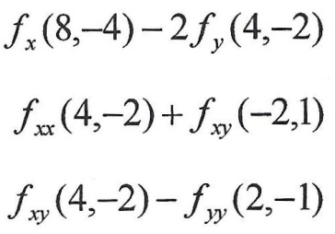

6. Express your opinion on each of the following claims:
- Given the implicit function 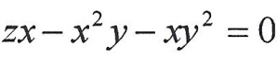, therefore 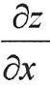 at point (1, 2) is equal to -2.
- Given the function 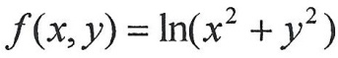, where 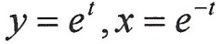. Therefore 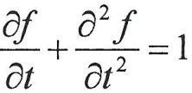
- Let g, h be functions with one variable, and let us define 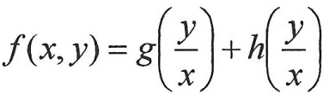 . Therefore, 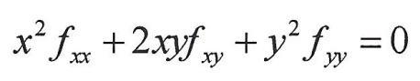
- The limit 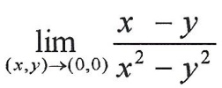does not exist.
- 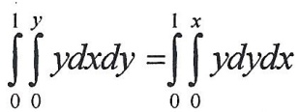
GOOD LUCK!

