Course no. 66-111 Date of exam: 31.7.14
Subject: Mathematics for economists
Duration of the exam: three hours

The discipline committee warns!
It is forbidden to remove the questionnaire from the exam room or copy it or photocopy it or mark it with a magic marker. It is absolutely forbidden to go to the bathroom. Once you have received the questionnaire/notebook, you must take the exam and return it. You may leave the exam room only after half an hour. It is forbidden to talk during the exam. Please comply with the supervisor’s instructions. Remove electronic devices, beeper and mobile phone. Holding a mobile phone, even if turned off, will lead to immediate invalidation of the exam. A student who will be found with forbidden auxiliary material or who will be caught cheating will be severely punished and may even be expelled from the university. A complaint will be submitted to the discipline committee against anyone transgressing these instructions.

I herewith declare that I have read and understood the instructions on the questionnaire and that I have no material in my possession that is forbidden for use.
ID no. ___________________ Signature ___________________________

Instructions

The exam contains 17 questions. Answer all the questions. Choose the correct answer and indicate it on the attached answers sheet.
If you indicate two answers, the answer will not be included in the count of correct answers. No auxiliary material may be used. A calculator can be used for calculations. The exam sheets and the notebook can be used for calculations. In no case will these pages be taken into account in determining the grade. You must return the exam sheet together with the answers sheet and the draft notebook.

GOOD LUCK!

Question no. 1
The limit 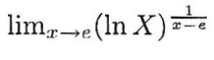is:
- 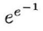
- e
- 1
- None of the other answers are correct.

Question no. 2
The limit 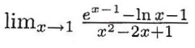 is:
- 1
- 0
- 0.5
- None of the other answers are correct.

Question no. 3
Ths solution of the integral 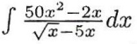 is:
1.  2. | 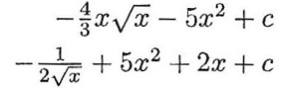
- We do not have the tools for solving this integral.
- None of the other answers are correct.

Question no. 4
The solution of the integral 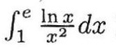is:
1.  2.  3. | 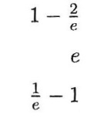
4. None of the other answers are correct.

Question no. 5
The solution of the integral 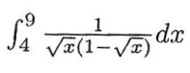is:
- -2 ln 2
- 1
- -3 ln 3
- 2.34

Question no. 6
Given a continuous function f (x) such that f (0) < 0. Which statement is correct?
1.  2.  3.  4. | 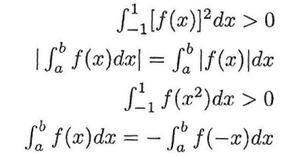

Question no. 7
Given the function 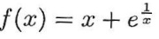. Then:
- The line y = x + 1 comprises both a right and a left asymptote to the function.
- The function does not have a right asymptote.
- The x axis comprises an asymptote to the function.
- The straight line y = x comprises an asymptote to the function.

Question no. 8
The function 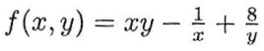
- Has one maximum point at (0.5, -4).
- Has one saddle point.
- Has one minimum point at (0.5, -4).
- The function has one minimum point and one maximum point.

Question no. 9
The approximate value of the expression 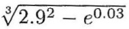, with the help of the differential, is:
- 1.9475
- 1.9469
- 1.9460
- None of the other answers are correct.

Question no. 10
A manufacturer is interested in producing 12 units of product at a minimal price. It is known that its production function is Q = K² + 2L². The price of one unit factor of production K is 1 and the price of one unit factor of production L is 2. Therefore, the optimal solution is:
- K = 2, L = 2
- K = √12, L = 0
- K = 0, L = √6
- None of the other answers are correct.

Question no. 11
Given the function: 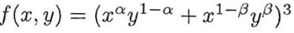
The value of 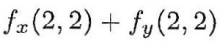 is:
- 96
- 64
- 32
- 128

Question no. 12
Given the function: f (x, y), and it is known that 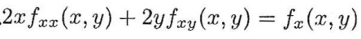 then:
- f_{x} (x, y) is homogeneous of degree 0.5
- f (x, y) is homogeneous of degree 1.5
- f_{x} (x, y) does not have to be a homogeneous function.
- f_{x} (x, y) is homogeneous of degree 2.
Question no. 13
Expansion of a Taylor series of the function √1 + x around the zero point is:
1.  2.  3. | 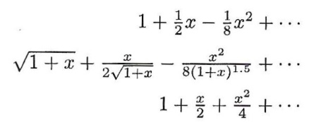
4. None of the other answers are correct.

Question no. 14
The limit 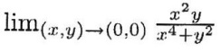is:
- The limit does not exist.
- The limit exists and is equal to 0.
- The limit exists and is equal to 0.5
- None of the other answers are correct.

Question no. 15
f (x, y) is a function with two variables, homogeneous, of degree 3. g (t) is a function with one variable. Given the function:
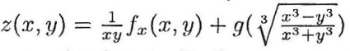
The value of the expression 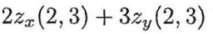is:
- 0
- z (x, y)
- There are not enough data for calculating this.
- 2z (x, y)

Question no. 16
Given the function:
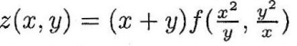 and it is known that:
Therefore, the value of z_{x} (2, 1) is:
- 26
- 29
- 11
- It cannot be calculated because there are not enough data.

Question no. 17
Given the function: 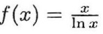
Claim A: The domain of the definition of the function is x > 0.
Claim B: At point x = e the function has a minimum point.
- Only claim B is correct.
- Only claim A is correct.
- Both claims are correct.
- Both claims are not correct.

