Course no. 66-111 Date of exam: 2013 moed A
Subject: Mathematics for economists
Duration of the exam: three hours
Auxiliary material: a calculator

1. Calculate the following limits:

A.  B. | 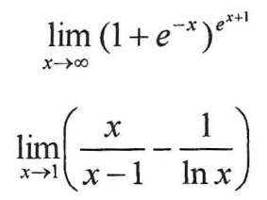

2. Calculate the following integrals:
A.  B.  C. | 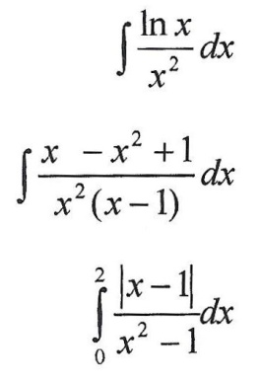

3. Investigate the function 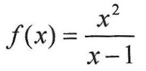 and draw its graph.

4. Calculate the minimum, maximum and saddle points of the function:
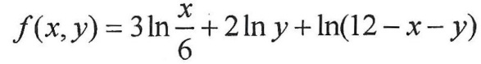
5. Given function f (x, y) in two variables and g (t) in one variables. It is known that
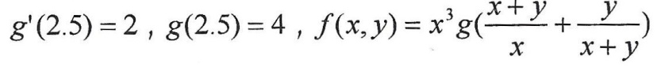
- Is f homogeneous? If so, of what degree?
- Calculate f_{x} at point (1, 1).
- Calculate 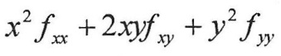 at point (1, 1).

6. Express your opinion on each of the following claims:
- The limit 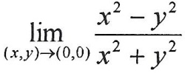does not exist.
- f (x, y) is homogeneous of degree 1, therefore the following exists:
1) 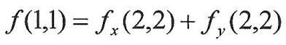
2) 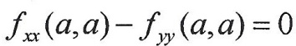 for a ≠ 0
- Given the implicit function 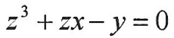, therefore 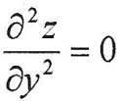
- g (x, y) is a homogeneous function of degree 2. We will define 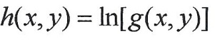, therefore h_{xx} is not a homogenous function.
- 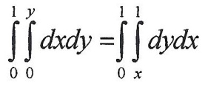
GOOD LUCK!

